While cikla ideja

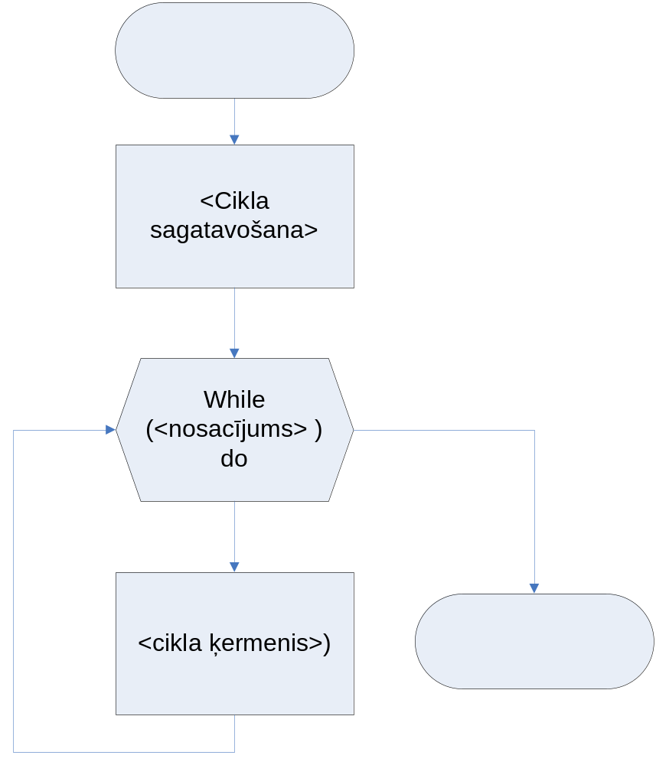

While cikla piemērs

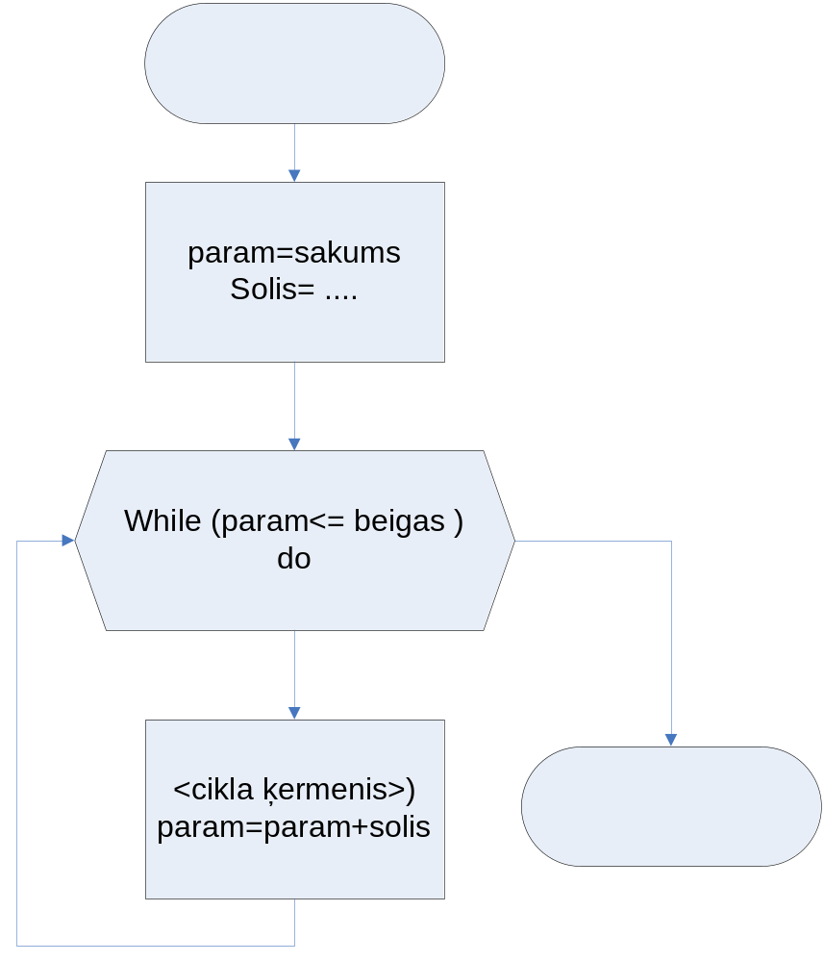

FOR TO cikls

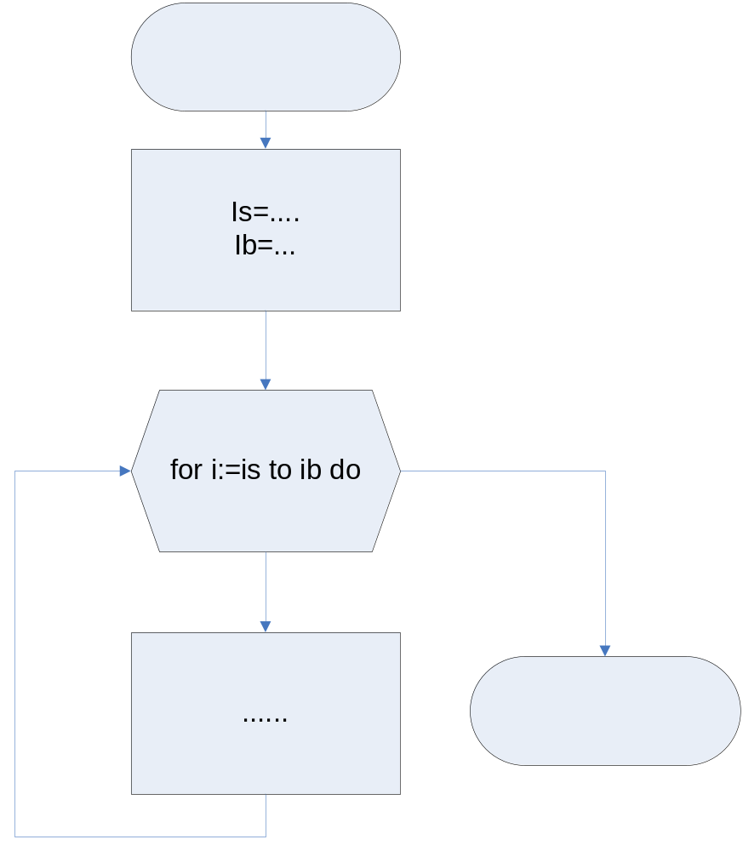

is:=1;
for i:=is to 15 do
begin
.....
.....
.....
end;

FOR DOWNTO cikls

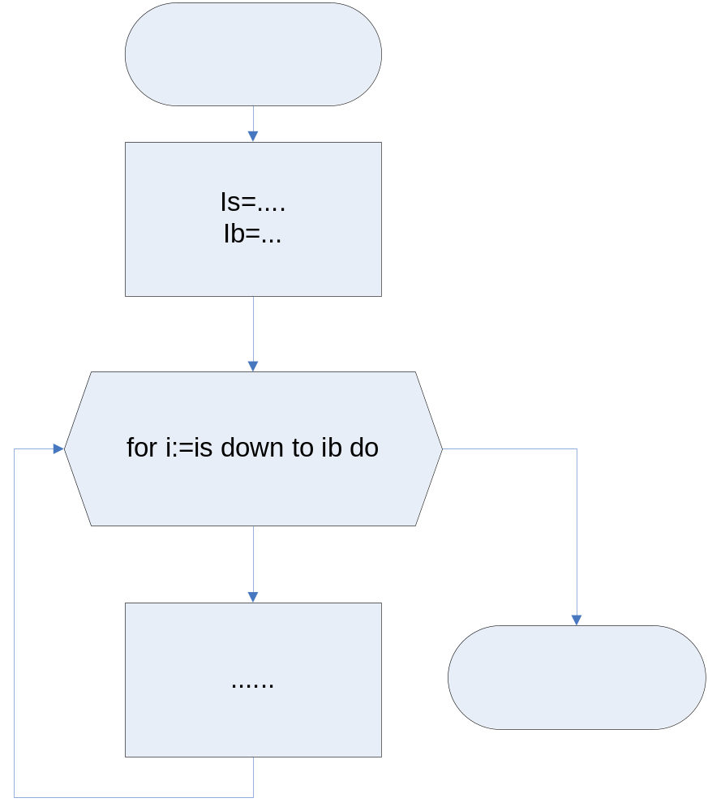

ib:=5;
for i:=25 downto ib do
begin
.....
.....
.....
end;

Repeat until cikls

